Git branch -–list command is used to list the branches.
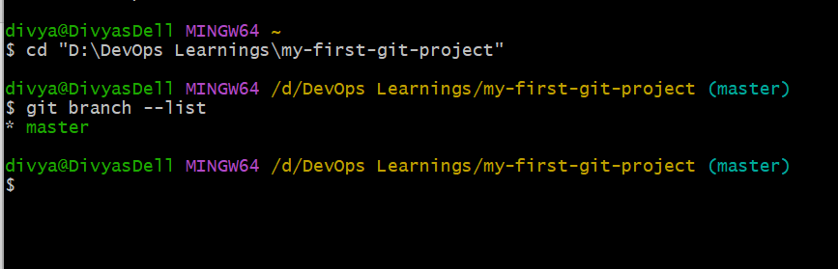
created a new file called “hello”, and added it to move from untracked to tracked
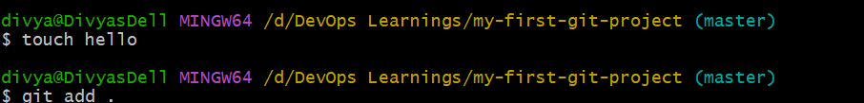
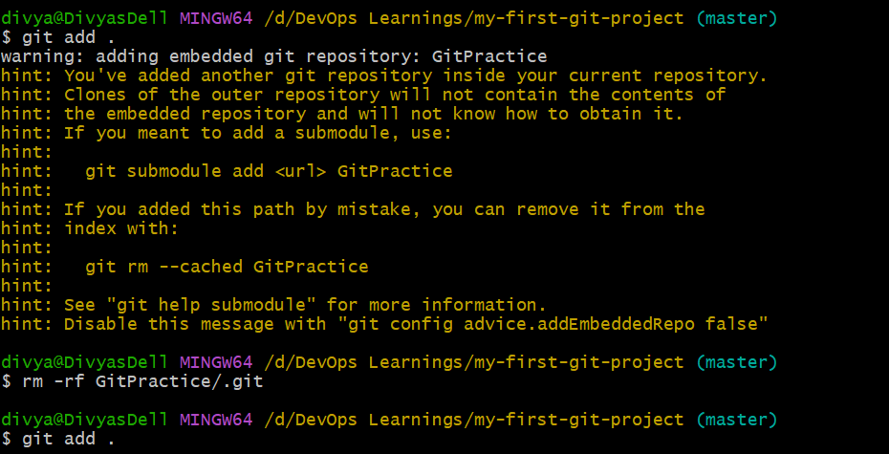
Status has been updated, and the file has been moved to the tracked file. and then committed them and checked the status everything is clean now.
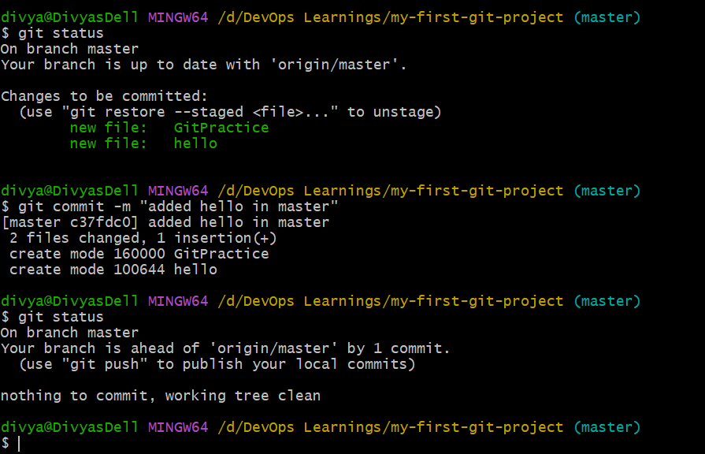
By running the command git branch release, we can create a branch called release.
